**Saving the Nature: Our Little Contributions Matter**

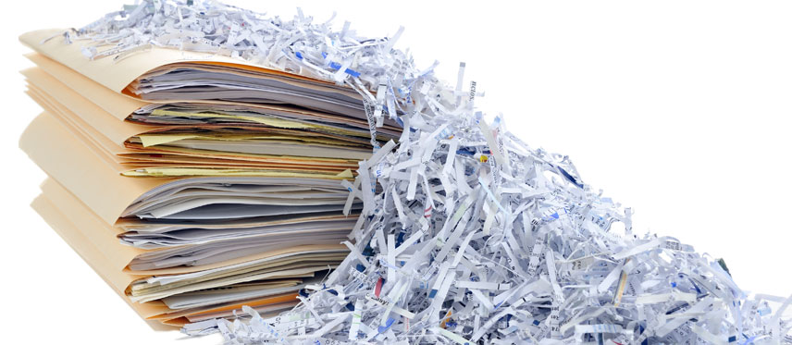Few days ago, our mathematics professor created a poll on the course forum. He asked students to vote whether they would like to have printed lecture slides, or they would bring their own formulae sheets for the end-term examinations. By the next day, all except two students had voted for printed lecture notes.

But this is not the end of story. Those two students were not satisfied with the voting results and therefore, they initiated a conversation, among students, about the paper wastage for printing the lectures, more than 300 pages per student, just for one-time use. And you might be surprised, but within few hours, more than half of the students changed their vote and chose to use 2 to 3 pages self-made formulae sheets. Most of us did not give it much thought before voting and chose to have lecture slides because why not, but thanks to the discussion, we realized that we actually did not need the lectures at all and as a result, a lot of paper was saved.

Our world is running out of natural resources, we are facing the threat of climate change, and many species are in danger of extinction. We know the problems around us, we talk about big problems and big solutions, but it is very rare that we actually think what we as individuals can do to save our fellow species in the ecosystem, the precious natural resources, and the sustainability of our planet.

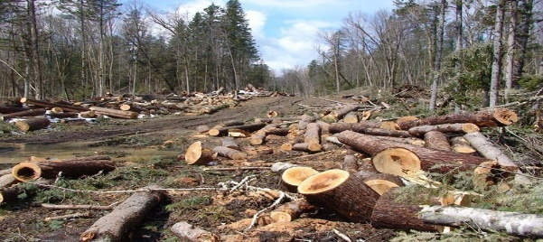Since we started with the unnecessary use of paper, let us look into the ways to minimize the consumption of paper in our daily lives and save those **3.5 billion to 7 billion** trees that are cut down each year for paper production. (Rainforest Action Network, 2017)

Saving paper is easy and doable. There are many simple steps that we can follow to save paper and the trees. For example,

* Unless you really need, using digital alternatives to paper-based documentation is much easier and efficient, also it saves time and money.
* Gifts do not really need extra prettiness of paper wraps and gift bags. At the end of the day, everything except main gift goes in trash.
* We can try to avoid using disposable paper cups and plates etc., as much as possible.

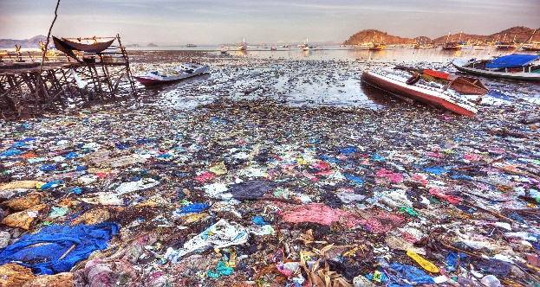Paper products are still recyclable and reusable to some extent. But plastic, which constitutes around 10% of all the waste produced in the world, is mostly non-recyclable. If we look around us, almost every packaged thing is plastic. According to a research by World Health Organization, half of the plastic we use is single-use or disposable, 1 million plastic bottles are bought every minute, up to 500 billion plastic bags are used per year, and at least 8 million tons of this plastic end up in the oceans each year. (World Environment Day, 2018)

This all plastic waste which ends up in sea to endanger marine life, burnt at informal waste sites to produce toxic gases and ruining the environment, or dumped at landfills, is very injurious to life. But plastic is so much involved in our daily lives that it seems impossible to completely buycott its consumption despite being aware of all the risks.

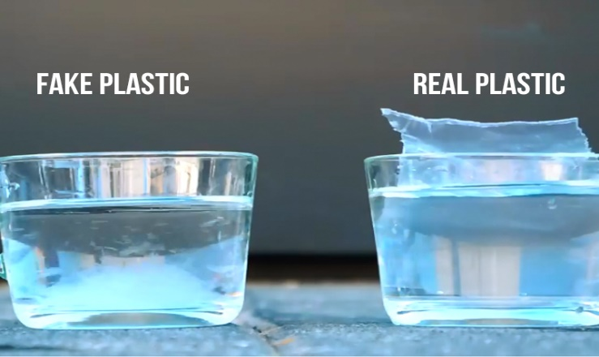But some genius people have found scientific solutions to plastic waste by creating biodegrable fake plastics. One such individual is Sharon Barack, a chemical engineer from Isreal, who has created a material called ‘Solutum’ plastic, which looks and feels like plastic, but can be biodegraded just by dissolving it in water, and it is so safe that you can even drink the water after dissolving Solutum in it. (Solutum Technology)

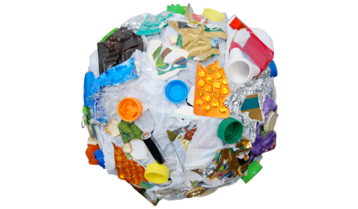While Solutum might not be a replacement to plastic containers for most liquids because of its water soluble nature, it can still replace the 500 billion plastic bags and lots of other packaging plastics used every year. For the rest, we need to avoid the use of plastic as much as possible by using stainless steel, glass or ceramic based replacements of utensils, bottles etc. We can also buy products that allow refills so that we do not make one more plastic container trash each time we run out of the product.

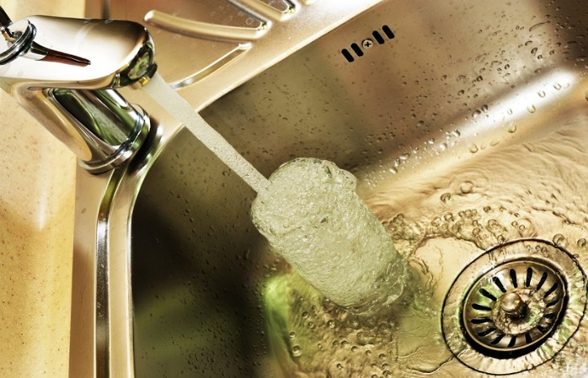Water is a vital resource for the survival of life. Currently, the world is facing the problems of water shortage and contamination, endangering all the life on earth. It is a responsibility of every single individual to try and save this precious resource. Even if you are not living in a region facing water related problems, saving water is a good choice, both economically and morally.

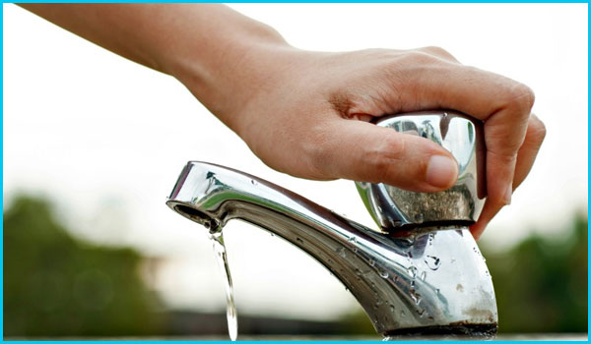There are many simple ways we can adopt to save water. For example,

* Using a bucket under the faucet while waiting for water to heat up. This water can be used for watering the plants or flushing toilet.
* Speeding up showers and washing.
* Turning off the tap quickly when water is not in use. For example, while brushing your teeth, scrubbing your dishes etc.
* Using less electricity. You will indirectly save a lot of water used for cooling down of power plants.

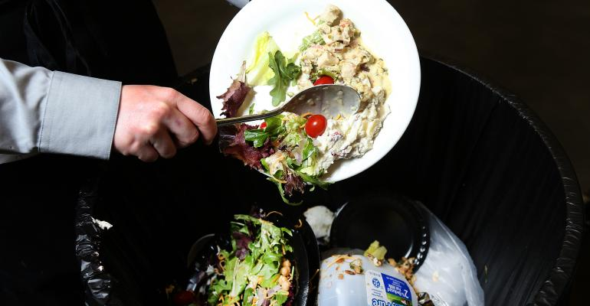A lot of water is wasted with wastage of food, another resource we need for survival. While modern and scientific ways have played great part in increased production of food, the world is still facing the issue of food shortage, the reason being inequality in distribution. According to WHO, around 600 million people face food-related illnesses and 0.42 million die every year. (Food Safety, 2017)

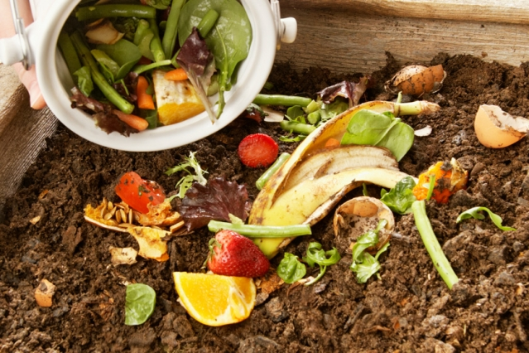

We can save food for the deprived ones by avoiding the wastage, and sharing the excess food with those in need rather than throwing it in trash. We can also use the food by-products and waste to return back nature’s favor by using it for composting, producing safe fertilizer for agriculture and production of healthier food.

While learning about what we can do individually to save the natural resources, I came across the term ‘Selective Empathy’ used by a famous video blogger, as he criticized how we focus on reducing the use of some resources, and keep wasting the others. (NAS Daily, 2018)

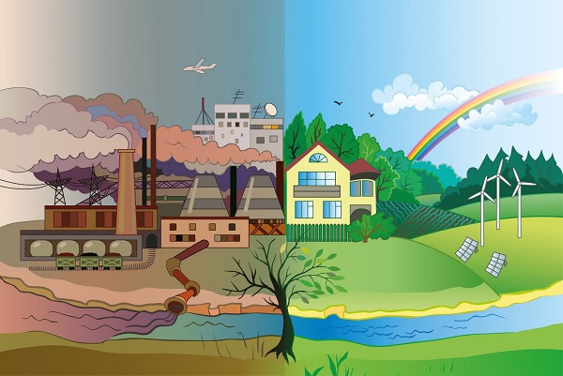In my opinion, however, selective empathy is okay, minimizing the use of some resources is better than not contributing at all. People should do as much as they can without feeling the burden for what they are not, since it will only discourage them, and they might end up doing nothing at all. We should respect and appreciate all the efforts. Even the very little contributions matter, and it is these little steps from many that make the huge impacts. We should keep trying to save our world and the precious resources for the better future we look forward to, for ourselves and the future generations.

# **References**

*Deaths from dirty water and related diseases*. (n.d.). Retrieved from The World Counts: http://www.theworldcounts.com/counters/interesting_water_facts/dirty_water_diseases

*Food Safety*. (2017, October 31). Retrieved from World Health Organization: https://www.who.int/news-room/fact-sheets/detail/food-safety

Rainforest Action Network. (2017, March 6). *How many trees are cut down every year?* Retrieved from The Understory: https://www.ran.org/the-understory/how_many_trees_are_cut_down_every_year/

*Solutum Technology*. (n.d.). Retrieved from Solutum: https://www.solutum.co/

*World Environment Day 2018: a call to “Beat plastic pollution”*. (2018, June 4). Retrieved from World Health Organization Regional Office for Eastern Mediterranean: http://www.emro.who.int/media/news/world-environment-day-2018-a-call-to-beat-plastic-pollution.html

Yassin, N. [NAS Daily]. (2018, December 21). *The Plastic Straw Dilemma.* Retrieved from <https://www.youtube.com/watch?v=Knb-xfBcBeg>